TROUBLESHOOTING STATIC AND DEFAULT ROUTERS

Why should I take this module?

Welcome to Troubleshoot Static and Default Routes!

Well done! You have come to the final module in the Switching, Routing, and Wireless Essentials v7.0 (SRWE) course. This course gave you the in-depth knowledge and skills you need to set up switches and routers (including wireless devices) on your growing network. You really are good at network administration!

But what makes a good network administrator into a great one? The ability to effectively troubleshoot. The best way to gain network troubleshooting skills is simple: always be troubleshooting. In this module, you will troubleshoot both static and default routes. There is a Syntax Checker, a Packet Tracer, and a hands-on Lab where you can hone your troubleshooting skills. Let’s get to it!

16.0.2

What will I learn to do in this module?

**Module Title**: Troubleshoot Static and Default Routes

**Module Objective**: Troubleshoot static and default route configurations.

| Table caption | |
| --- | --- |
| **Topic Title** | **Topic Objective** |
| **Packet Processing with Static Routes** | Explain how a router processes packets when a static route is configured. |
| **Troubleshoot IPv4 Static and Default Route Configuration** | Troubleshoot common static and default route configuration issues. |

PACKET PROCESSING WITH STATIC ROUTES

16.1.1

Static Routes and Packet Forwarding

Before diving into the troubleshooting portion of this module, this topic provides a brief review of how packets are forwarded in static routes. In the figure, click Play to see the animation where PC1 is sending a packet to PC3.

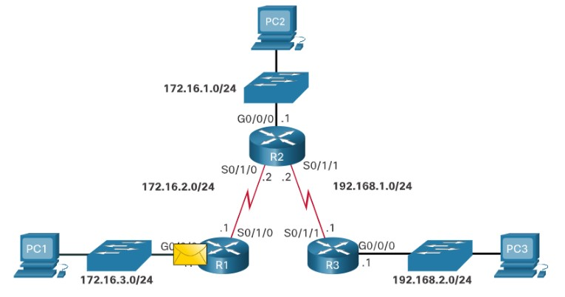

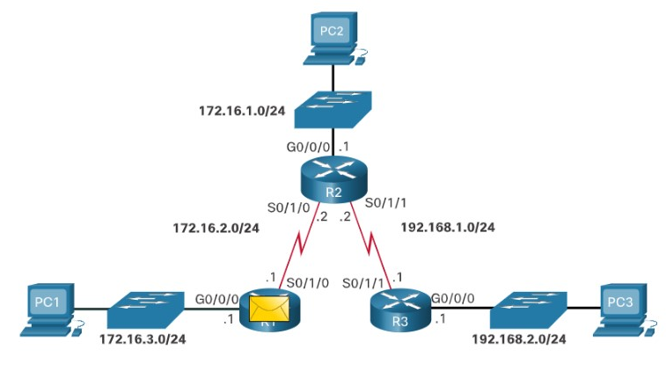

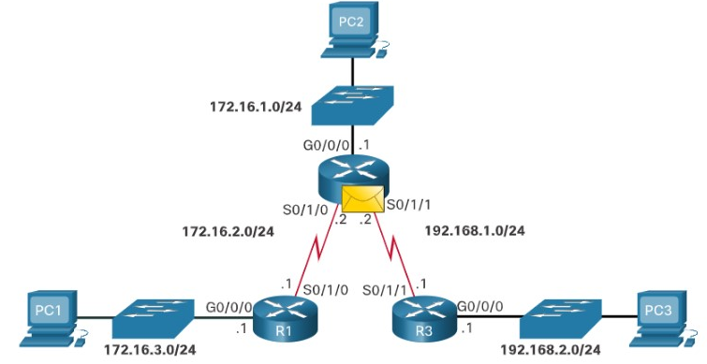

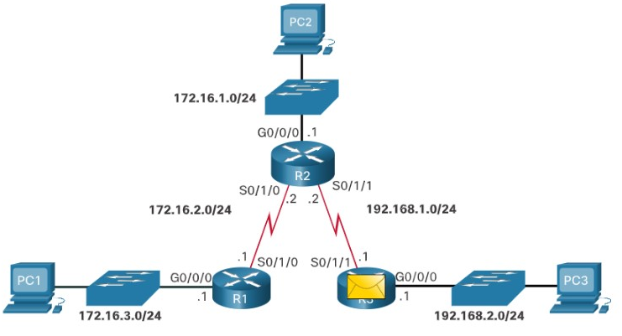

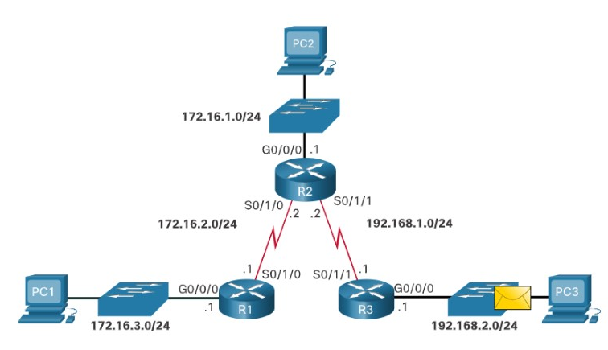

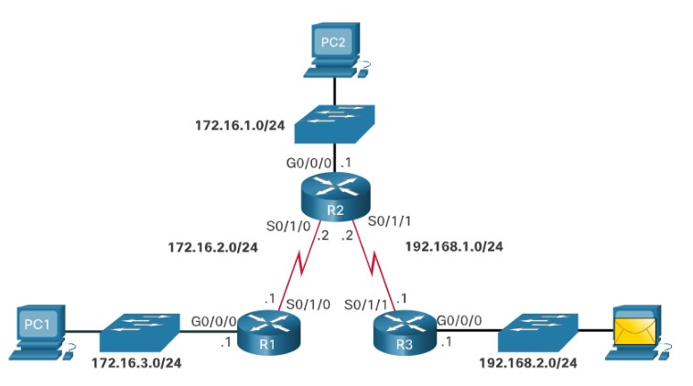

The following describes the packet forwarding process with static routes, as demonstrated in the animation:

1. The packet arrives on the GigabitEthernet 0/0/0 interface of R1.
2. R1 does not have a specific route to the destination network, 192.168.2.0/24. Therefore, R1 uses the default static route.
3. R1 encapsulates the packet in a new frame. Because the link to R2 is a point-to-point link, R1 adds an "all 1s" address for the Layer 2 destination address.
4. The frame is forwarded out of the Serial 0/1/0 interface. The packet arrives on the Serial 0/1/0 interface on R2.
5. R2 de-encapsulates the frame and looks for a route to the destination. R2 has a static route to 192.168.2.0/24 out of the Serial 0/1/1 interface.
6. R2 encapsulates the packet in a new frame. Because the link to R3 is a point-to-point link, R2 adds an "all 1s" address for the Layer 2 destination address.
7. The frame is forwarded out of the Serial 0/1/1 interface. The packet arrives on the Serial 0/1/1 interface on R3.
8. R3 de-encapsulates the frame and looks for a route to the destination. R3 has a connected route to 192.168.2.0/24 out of the GigabitEthernet 0/0/0 interface.
9. R3 looks up the ARP table entry for 192.168.2.10 to find the Layer 2 Media Access Control (MAC) address for PC3. If no entry exists, R3 sends an Address Resolution Protocol (ARP) request out of the GigabitEthernet 0/0/0 interface, and PC3 responds with an ARP reply, which includes the PC3 MAC address.
10. R3 encapsulates the packet in a new frame with the MAC address of the GigabitEthernet 0/0/0 interface as the source Layer 2 address, and the MAC address of PC3 as the destination MAC address.
11. The frame is forwarded out of GigabitEthernet 0/0/0 interface. The packet arrives on the network interface card (NIC) interface of PC3.
12. **Refer to the exhibit.** True or False? R1 must encapsulate received packets into new frames before forwarding them to R2.



True



False

**ANS: The correct answer is True. Because R2 is on a different L2 segment than PC1, R1 must de-encapsulate received packets from PC1 and re-encapsulate them in a new L2 frame to forward to R2.**

1. **Refer to the exhibit.** True or False? R2 will forward frames to R3 with an all 1s Layer 2 address.



True



False

**ANS: The correct answer is True. The point-to-point link between R2 and R3 uses the destination address of all 1s.**

1. **Refer to the exhibit.** What action will R3 take to forward a frame if it does not have an entry in the ARP table to resolve a destination MAC address?



sends a DNS request



drops the frame



sends an ARP request



sends frame to the default gateway

**ANS: R3 will send an ARP request to resolve the Layer 2 address of the destination host**

**Troubleshoot IPv4 Static and Default Route Configuration**

16.2.1

Network Changes

No matter how well you set up your network, you will have to be ready to troubleshoot some problem. Networks are frequently subject to events that can cause their status to change. For example, an interface can fail, or a service provider drops a connection. Links can become oversaturated, or an administrator may enter a wrong configuration.

When there is a change in the network, connectivity may be lost. Network administrators are responsible for pinpointing and solving the problem. To find and solve these issues, a network administrator must be familiar with tools to help isolate routing problems quickly.

16.2.2

Common Troubleshooting Commands

Common IOS troubleshooting commands include the following:

* **ping**
* **traceroute**
* **show ip route**
* **show ip interface brief**
* **show cdp neighbors detail**

The figure shows the topology used to demonstrate these commands.

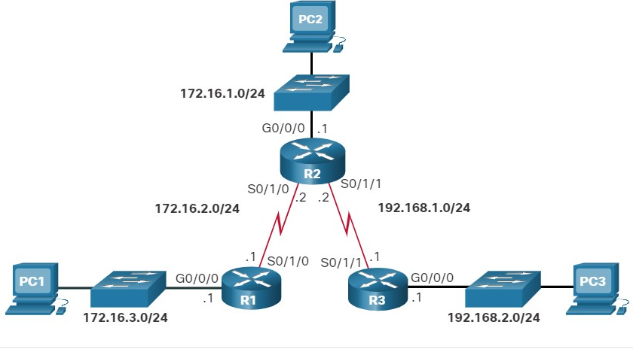

**ping**

The example displays the result of an extended ping from the source interface of R1 to the LAN interface of R3. An extended ping is an enhanced version of the ping utility. Extended ping enables you to specify the source IP address for the ping packets.

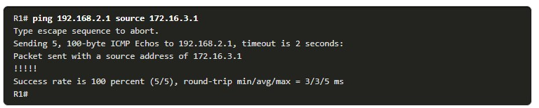

**traceroute**

This example displays the result of a traceroute from R1 to the R3 LAN. Note that each hop route returns an ICMP reply.

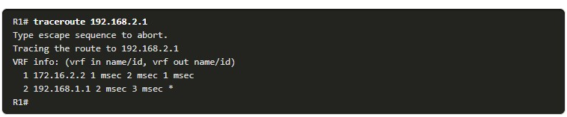

**show ip route**

The **show ip route** command in this example displays the routing table of R1.

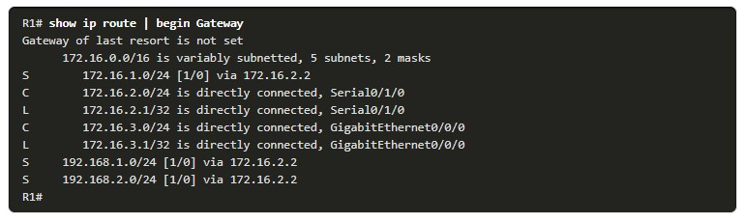

**show ip interface brief**

A quick status of all interfaces on the router is shown using the **show ip interface brief** command in this example.

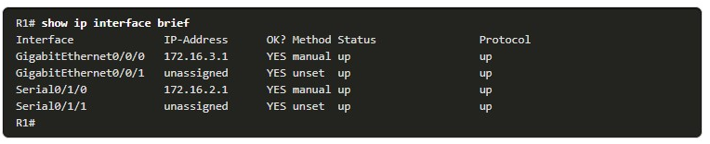

**show cdp neighbors**

The **show cdp neighbors** command provides a list of directly connected Cisco devices. This command validates Layer 2 (and therefore Layer 1) connectivity. For example, if a neighbor device is listed in the command output, but it cannot be pinged, then Layer 3 addressing should be investigated.

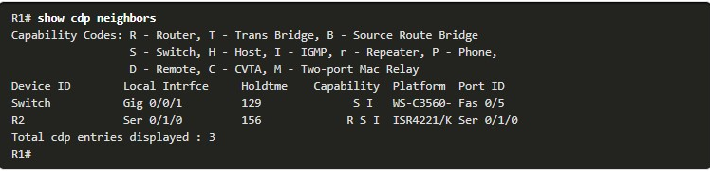

16.2.3

## Solve a Connectivity Problem

Finding a missing (or misconfigured) route is a relatively straightforward process if the right tools are used in a methodical manner.

For instance, the user at PC1 reports that he cannot access resources on the R3 LAN. This can be confirmed by pinging the LAN interface of R3 using the LAN interface of R1 as the source. Again, we will use the topology in the figure to demonstrate how to troubleshoot this connectivity problem.

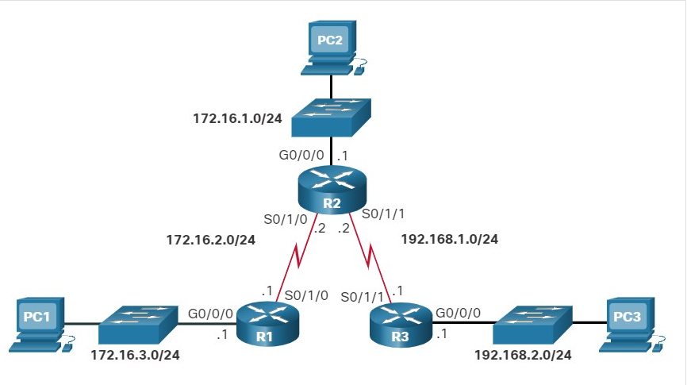

Click each button to see how troubleshooting commands are used to solve a connectivity problem.

**Ping the Remote LAN**

The network administrator can test connectivity between the two LANs from R1 instead of PC1. This can be done by sourcing the ping from the G0/0/0 interface on R1 to the G0/0/0 interface on R3, as shown in the example. The ping results show that there is no connectivity between these LANs.

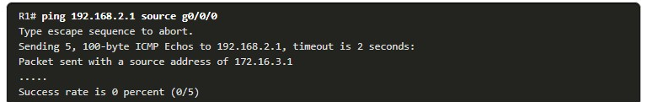

Ping the Next-Hop Router

Next, a ping to the S0/1/0 interface on R2 is successful. This ping is sourced from the S0/1/0 interface of R1. Therefore, the issue is not loss of connectivity between R1 and R2.

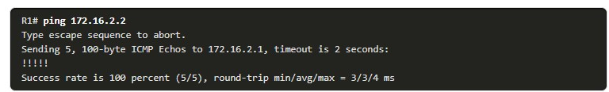

Ping R3 LAN from S0/1/0

A ping from R1 to the R3 interface 192.168.2.1 is successful as well. This ping is sourced from the S0/1/0 interface on R1. R3 has a route back to the network between R1 and R2, 172.16.2.0/24. This confirms that R1 can reach the remote LAN on R3. However, packets sourced from the LAN on R1 cannot. This indicates that either R2 or R3 may have an incorrect or missing route to the LAN on R1.

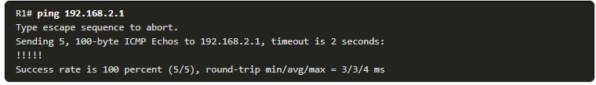

Verify the R2 Routing Table

The next step is to investigate the routing tables of R2 and R3. The routing table for R2 is shown in the example. Notice that the 172.16.3.0/24 network is configured incorrectly. The static route to the 172.16.3.0/24 network has been configured using the next-hop address 192.168.1.1. Therefore, packets destined for the 172.16.3.0/24 network are sent back to R3 instead of to R1.

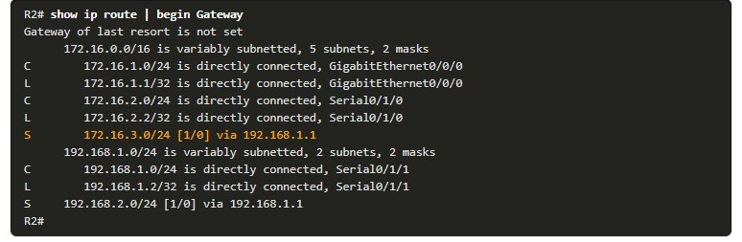

**Correct the R2 Static Route Configuration**

Next, the running configuration does, in fact, reveal the incorrect **ip route** statement. The incorrect route is removed, and the correct route is then entered.

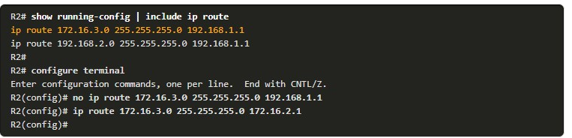

**Verify New Static Route is Installed**

The routing table on R2 is checked once again to confirm the route entry to the LAN on R1, 172.16.3.0, is correct and pointing toward R1.

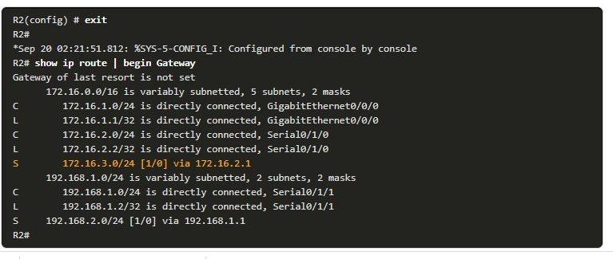

**Ping the Remote LAN Again**

Next, a ping from R1 sourced from G0/0/0 is used to verify that R1 can now reach the LAN interface of R3. As a last step in confirmation, the user on PC1 should also test connectivity to the 192.168.2.0/24 LAN.

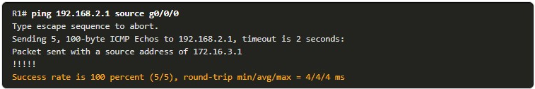

16.3.1

Packet Tracer - Troubleshoot Static and Default Routes(pending 16.3.1)

In this activity you will troubleshoot and static and default routes and repair any errors that you find.

* Troubleshoot IPv4 static routes.
* Troubleshoot IPv6 static routes.
* Configure IPv4 static routes.
* Configure IPv4 default routes.
* Configure IPv6 static routes.

16.3.2

## Lab - Troubleshoot IPv4 and IPv6 Static and Default Routes(pending)

##### **Skills Practice Opportunity**

You have the opportunity to practice the following skills:

* Part 1: Evaluate Network Operation
* Part 2: Gather Information, Create an Action Plan, and Implement Corrections

You can practice these skills using the Packet Tracer or lab equipment, if available.

**Packet Tracer - Physical Mode (PTPM)**

16.3.3

What did I learn in this module?

**Packet Processing with Static Routes**

1. The packet arrives on the interface of R1.
2. R1 does not have a specific route to the destination network; therefore, R1 uses the default static route.
3. R1 encapsulates the packet in a new frame. Because the link to R2 is a point-to-point link, R1 adds an "all 1s" address for the Layer 2 destination address.
4. The frame is forwarded out of the appropriate interface. The packet arrives on the interface on R2.
5. R2 de-encapsulates the frame and looks for a route to the destination. R2 has a static route to the destination network out of one of its interfaces.
6. R2 encapsulates the packet in a new frame. Because the link to R3 is a point-to-point link, R2 adds an "all 1s" address for the Layer 2 destination address.
7. The frame is forwarded out of the appropriate interface. The packet arrives on the interface on R3.
8. R3 de-encapsulates the frame and looks for a route to the destination. R3 has a connected route to the destination network out of one of its interfaces.
9. R3 looks up the ARP table entry for the destination network to find the Layer 2 MAC address for PC3. If no entry exists, R3 sends an ARP request out of one of its interfaces, and PC3 responds with an ARP reply, which includes the PC3 MAC address.
10. R3 encapsulates the packet in a new frame with the MAC address of the appropriate interface as the source Layer 2 address and the MAC address of PC3 as the destination MAC address.
11. The frame is forwarded out of the appropriate interface. The packet arrives on the network interface card (NIC) interface of PC3.

**Troubleshoot IPv4 Static and Default Route Configuration**

Networks are frequently subject to events that can cause their status to change. An interface can fail, or a service provider drops a connection. Links can become oversaturated, or an administrator may enter a wrong configuration. Common IOS troubleshooting commands include the following:

* **ping**
* **traceroute**
* **show ip route**
* **show ip interface brief**
* **show cdp neighbors detail**

16.3.4

Module Quiz - Troubleshoot Static and Default Routes

Top of Form

1. Which sequence correctly identifies the order of the steps that a router will perform when it receives a packet on an Ethernet interface?

Topic 16.1.0 - When a router receives a packet the first thing that happens is the destination MAC address is checked to verify that the rest of the packet should be processed. Assuming the destination MAC address matches the address on the router interface, the Ethernet Type field is checked to determine what Layer 3 protocol is encapsulated in the frame. The frame is then de-encapsulated and the destination IP address is examined to determine where the packet should be sent.



* 1. The router examines the destination MAC address.
  2. The router identifies the Ethernet Type field.
  3. The router examines the destination IP address.
  4. The router de-encapsulates the Ethernet frame.



* 1. The router examines the destination IP address.
  2. The router examines the destination MAC address.
  3. The router identifies the Ethernet Type field.
  4. The router de-encapsulates the Ethernet frame.



* 1. The router examines the destination MAC address.
  2. The router identifies the Ethernet Type field.
  3. The router de-encapsulates the Ethernet frame.
  4. The router examines the destination IP address.



* 1. The router examines the destination IP address.
  2. The router examines the destination MAC address.
  3. The router de-encapsulates the Ethernet frame.
  4. The router identifies the Ethernet Type field.



* 1. The router de-encapsulates the Ethernet frame.
  2. The router examines the destination MAC address.
  3. The router identifies the Ethernet Type field.
  4. The router examines the destination IP address.

1. Which three IOS troubleshooting commands can help to isolate problems with a static route? (Choose three.)

Topic 16.2.0 - The **ping**, **show ip route**, and **show ip interface brief** commands provide information to help troubleshoot static routes. **Show version** does not provide any routing information. The **tracert** command is used at the Windows command prompt and is not an IOS command. The **show arp** command displays learned IP address to MAC address mappings contained in the Address Resolution Protocol (ARP) table.



**show arp**



**tracert**



**show version**



**show ip route**



**show ip interface brief**



**ping**

1. A network administrator has entered a static route to an Ethernet LAN that is connected to an adjacent router. However, the route is not shown in the routing table. Which command would the administrator use to verify that the exit interface is up?

Topic 16.2.0 - The network administrator should use the **show ip interface brief** command to verify that the exit interface or the interface connected to the next hop address is up and up. The **show ip route** command has already been issued by the administrator. The **show ip protocols** command is used when a routing protocol is enabled. The **tracert** command is used from a Windows PC.



**tracert**



**show ip protocols**



**show ip interface brief**



**show ip route**

1. A static route has been configured on a router. However, the destination network no longer exists. What should an administrator do to remove the static route from the routing table?

Topic 16.2.0 - When the destination network specified in a static route does not exist anymore, the static route stays in the routing table until it is manually removed by using the **no ip route** command.



Change the administrative distance for that route.



Change the routing metric for that route.



Nothing. The static route will go away on its own.



Remove the route using the **no ip route** command.

1. Which statement describes the sequence of processes executed by a router when it receives a packet from a host to be delivered to a host on another network?

Topic 16.1.0 - The router receives the packet, de-encapsulates it to select the appropriate path, encapsulates the packet, and then forwards it toward the destination host.



It receives the packet and forwards it directly to the destination host.



It de-encapsulates the packet, selects the appropriate path, and encapsulates the packet to forward it toward the destination host.



It selects the path and forwards it toward the destination host.



It de-encapsulates the packet and forwards it toward the destination host.

1. A network engineer issues the **show cdp neighbor** command on several network devices during the process of network documentation. What is the purpose of performing this command?

Topic 16.2.0 - The **show cdp neighbor** command is used to obtain detailed information about directly connected Cisco devices. The information does not include which networks are attached to the neighboring Cisco devices nor the connectivity of PCs that are attached to them. The **show ip route** command is used to view the networks that are advertised from neighboring routers.



to obtain information about directly connected Cisco devices



to verify the network addresses that are attached to the network devices



to check the connectivity of PCs that are connected to the network devices



to check the networks that are advertised by the neighboring routers

1. A network administrator notices that a correctly entered static route is not in the routing table. What two router commands would an administrator use to determine if the exit interface was up and the next hop address is available? (Choose two.)

Topic 16.2.0 - The network administrator could use the **show ip interface brief** command to verify that the exit interface or the interface connected to the next hop address is up and up. The **ping** command can be used to see if the next hop address is reachable. The **show ip route** command displays the routing table. The **show ip protocols** command is used when a routing protocol is enabled. The **tracert** command is used from a Windows PC.



**ping**



**show ip protocols**



**show ip route**



**show ip interface brief**



**tracert**

1. A network administrator has entered the following command:

**ip route 192.168.10.64 255.255.255.192 serial0/0/1**

When the network administrator enters the command **show ip route**, the route is not in the routing table. What should the administrator do next?

Topic 16.2.0 - The reason that a correctly typed static network would not go into the routing table is if the exit interface is not available. The 192.168.10.64 is a valid network number and that route does not have to be "up and up" in order for a static route to be configured on a remote router.



Verify that the 192.168.10.64 network is active within the network infrastructure.



Verify that the serial 0/0/1 interface is active and available.



Re-enter the command using a network number rather than a usable IP address.



Re-enter the command using the correct mask.

1. What will a router do if it does not have a default route configured and a packet needs to be forwarded to a destination network that is not listed in the routing table?

Topic 16.1.0 - A router will only forward packets if it has the destination network in its routing table. If it receives a packet with a destination network that is not in the routing table, the router will drop it. A default route can be installed on a router to make the router forward packets to another router that can route the packet to its destination.



forward it to another router



drop it



send it back to the source

1. What does the letter C mean next to an entry in the output of the **show ip route** command?

Topic 16.2.0 - In a routing table, the label C identifies a network that is directly connected to an interface on the device. This entry is added to the routing table when an interface is configured with an IP address and activated.



It identifies a network that is learned through OSPF.



It identifies a network that is directly connected to the router.



It identifies a network that is a static route.



It identifies a network that is learned through EIGRP.

s